How to Set Up Google Search Console

Step 1: Go to Google Search Console
To set up GSC, you’ll need a Google account and access to your website.
Go to https://search.google.com/search-console
Here’s how to add a URL prefix property:
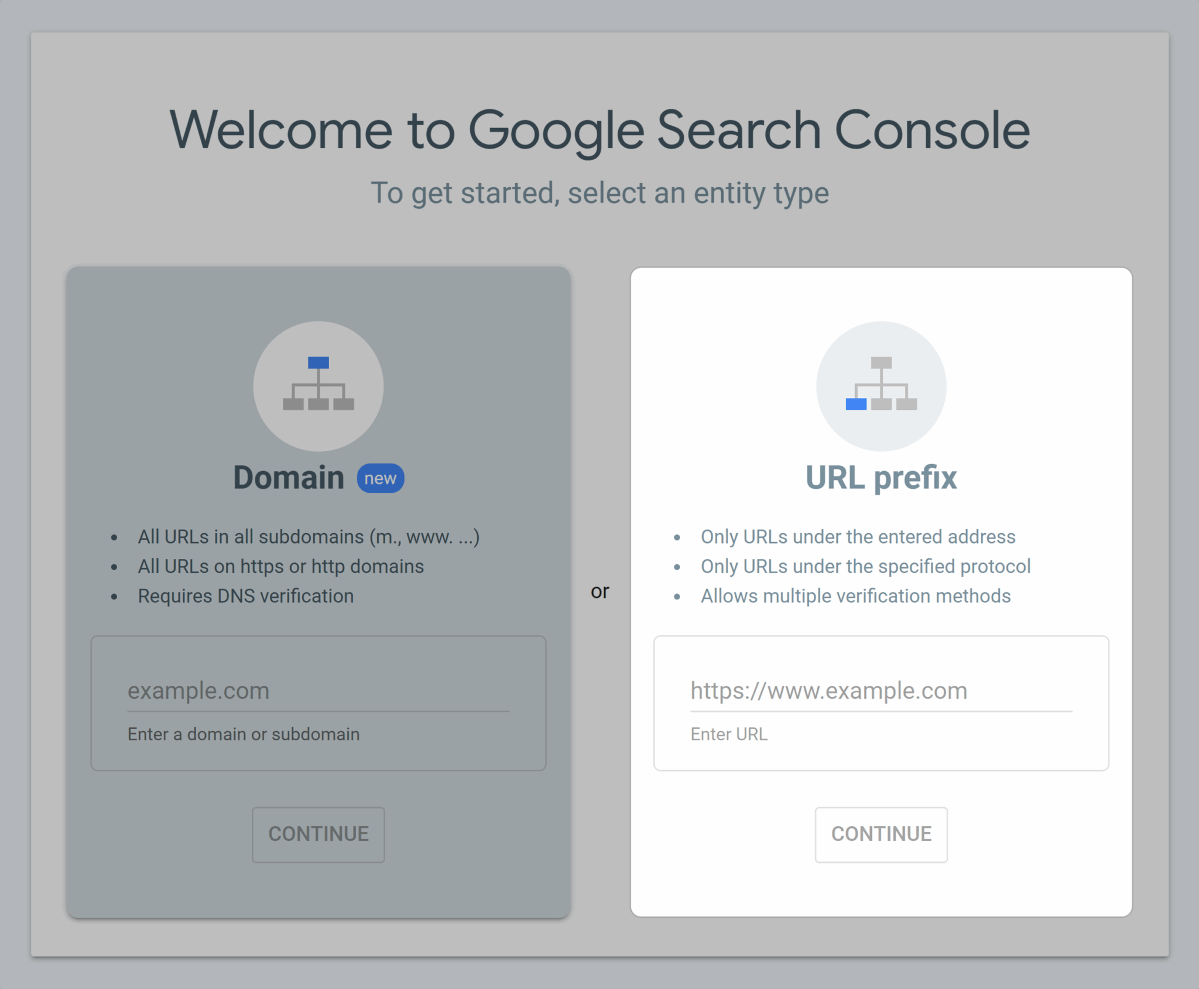
- Under the URL prefix section of the first page of GSC, type the full URL of the site or section you want to track.
Example: https://www.example.com/blog
Then click “Continue.”
- Google will show you several ways to verify your property:
- HTML file upload (recommended)
- HTML tag
- Google Analytics
- Google Tag Manager
- Domain name provider
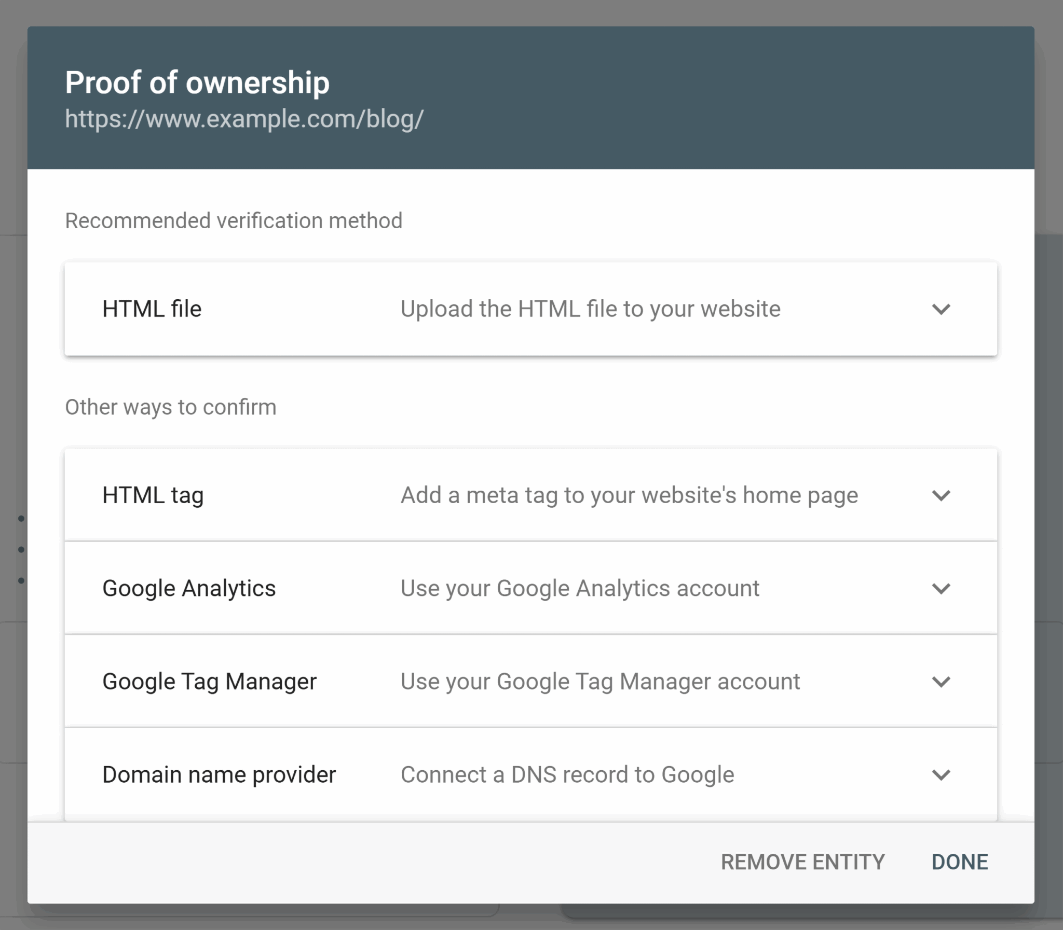

Try Google’s recommended method: HTML file upload.
- Expand the “HTML file” section and click to download the verification file
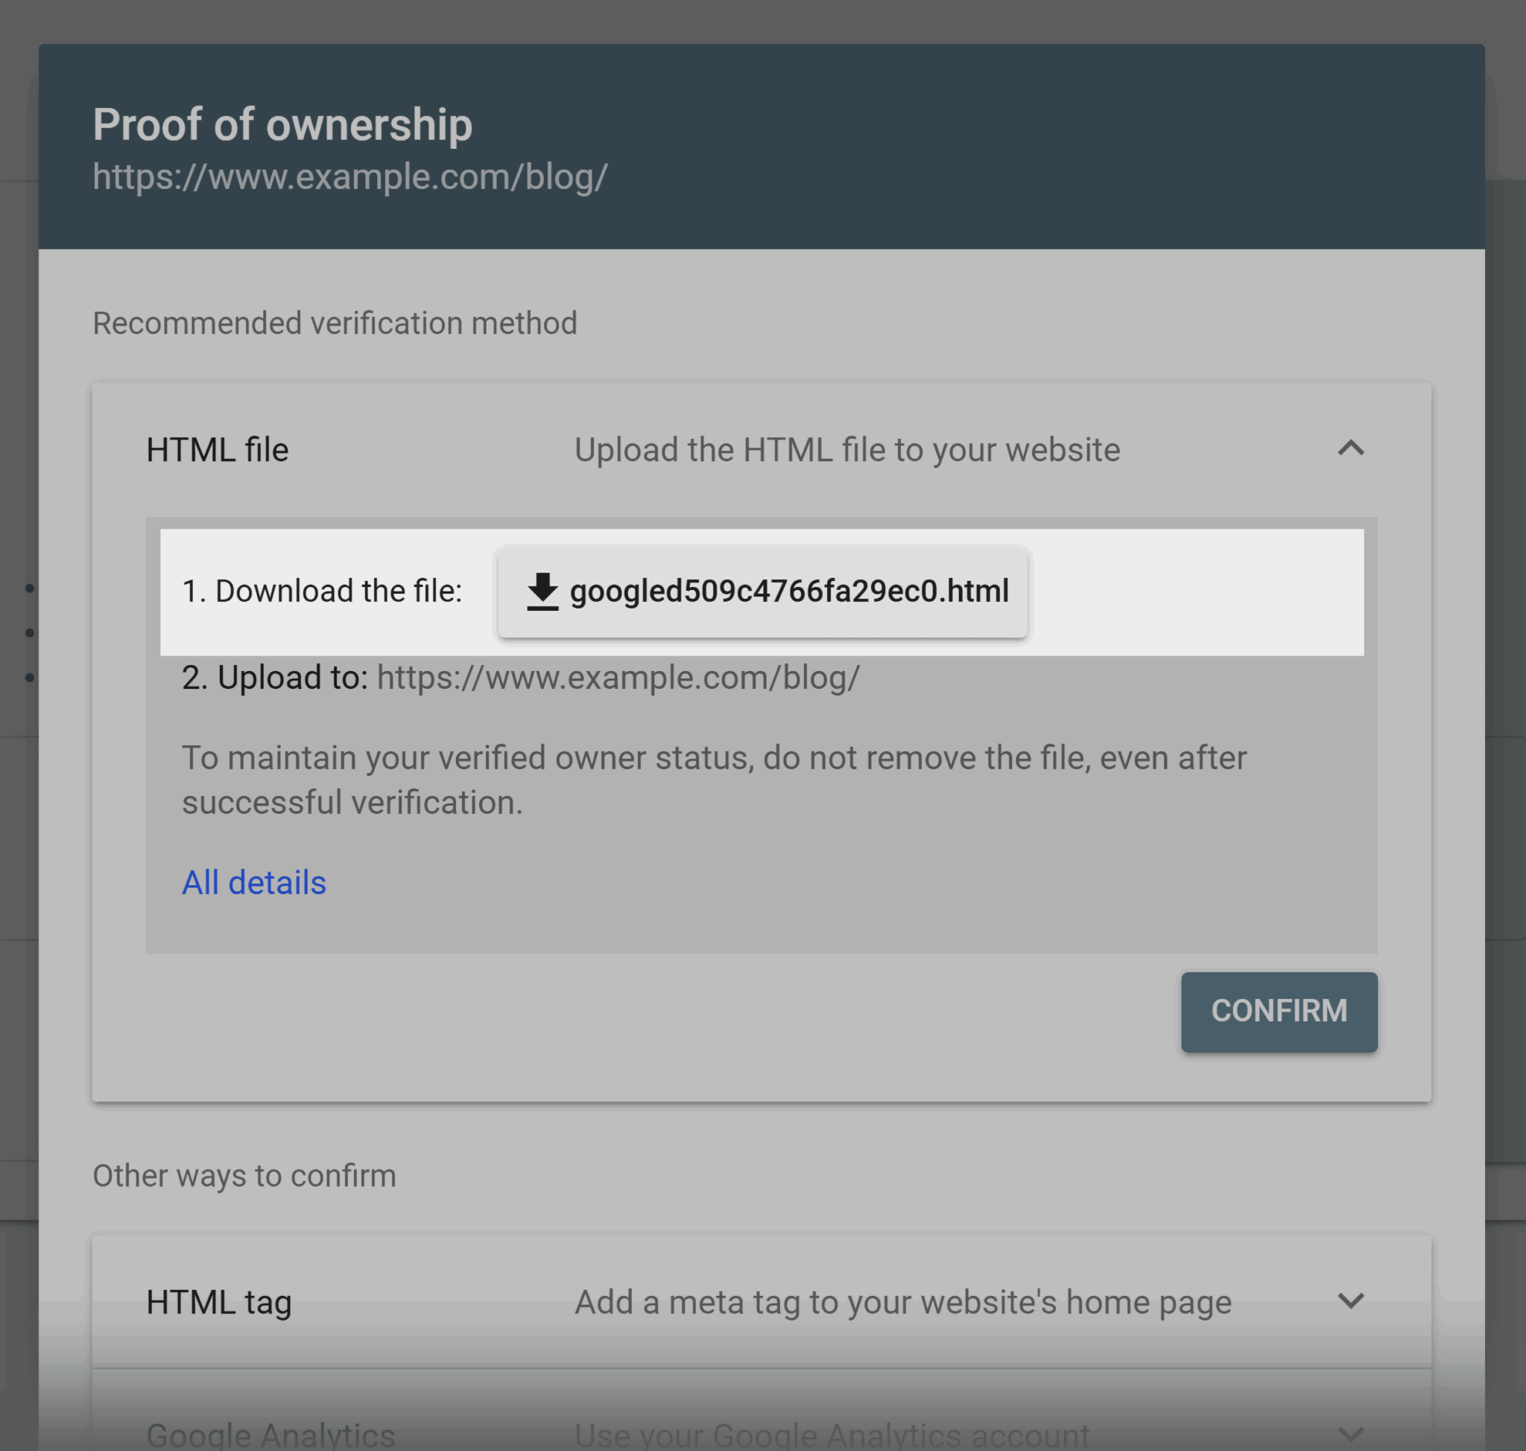

- Upload this file into your website’s root directory:
- If you want to verify www.example.com, upload it to the homepage directory
- If you’re verifying www.example.com/blog, upload it into the blog folder
- Once the file is uploaded, go back to Search Console and click “Confirm” or “Verify“
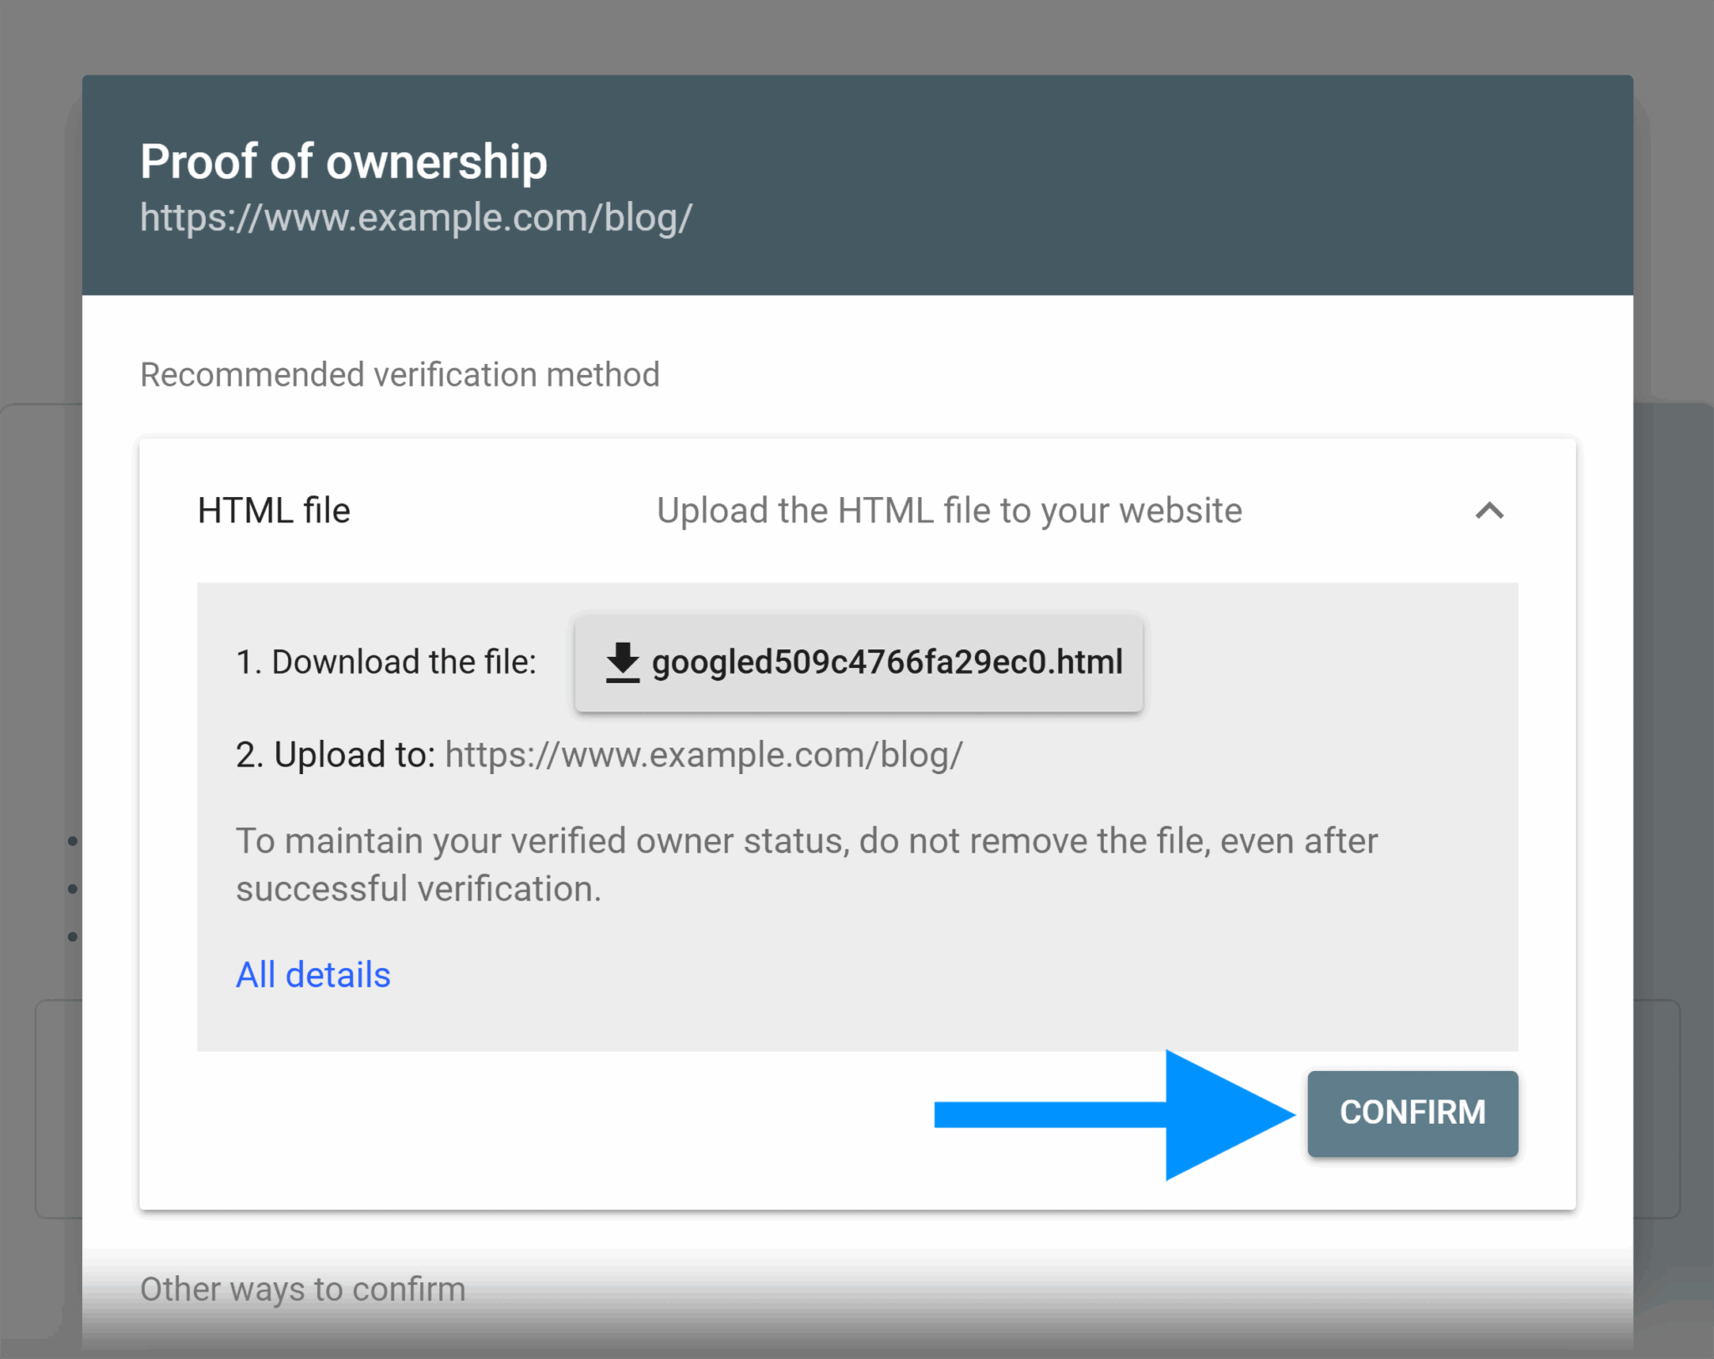

Step 3: Verify Your Ownership
Once you’ve added your property in Google Search Console (whether by domain or URL prefix), the next step is to prove that you actually own the site. This is Google’s way of keeping things secure; it won’t show sensitive performance data to just anyone.

If you added a URL Prefix Property:
You’ll verify using one of Google’s supported methods. These are your options:
- HTML file upload (recommended)
- HTML tag
- Google Analytics
- Google Tag Manager
- Domain name provider
Let’s walk through the HTML file upload method (the one we used earlier):
- Make sure you’ve uploaded the verification file to your site’s root directory
- Go back to Google Search Console
- Click “Verify” or “Confirm“
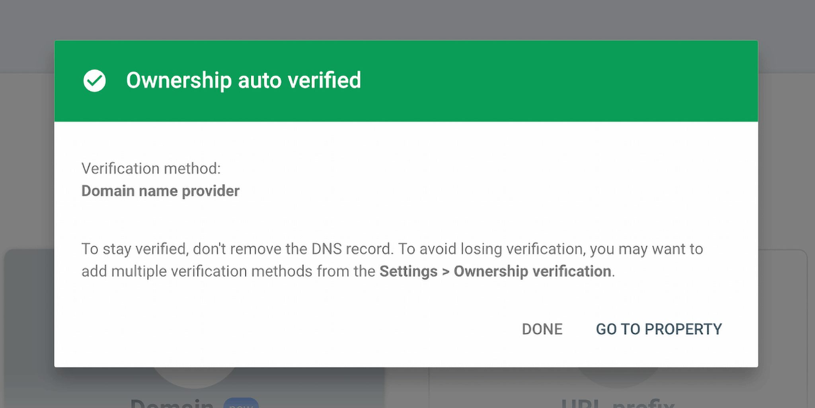

If your verification doesn’t go through:
- Double-check that the file is in the right folder
- Make sure the file name hasn’t changed during download/upload
- Wait a few minutes and try again

How to add a new user

If you’re an owner, you can give other people access to your website’s Search Console account. Here’s how:
- Go to your property in Google Search Console
- In the left-hand menu, click on “Settings”
- Select “Users and permissions”
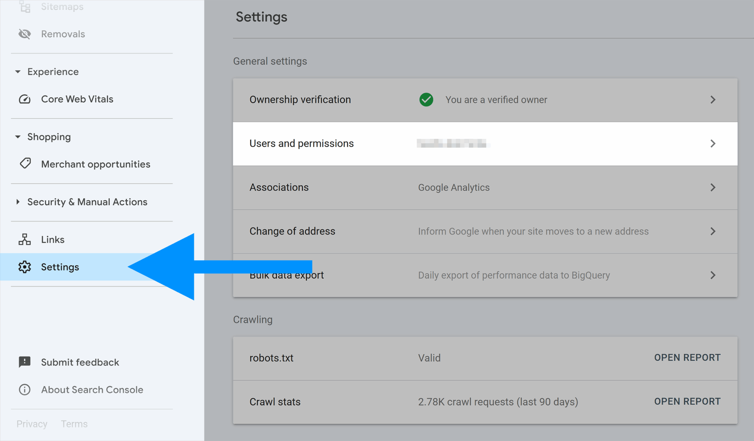

- Click the “Add user” button
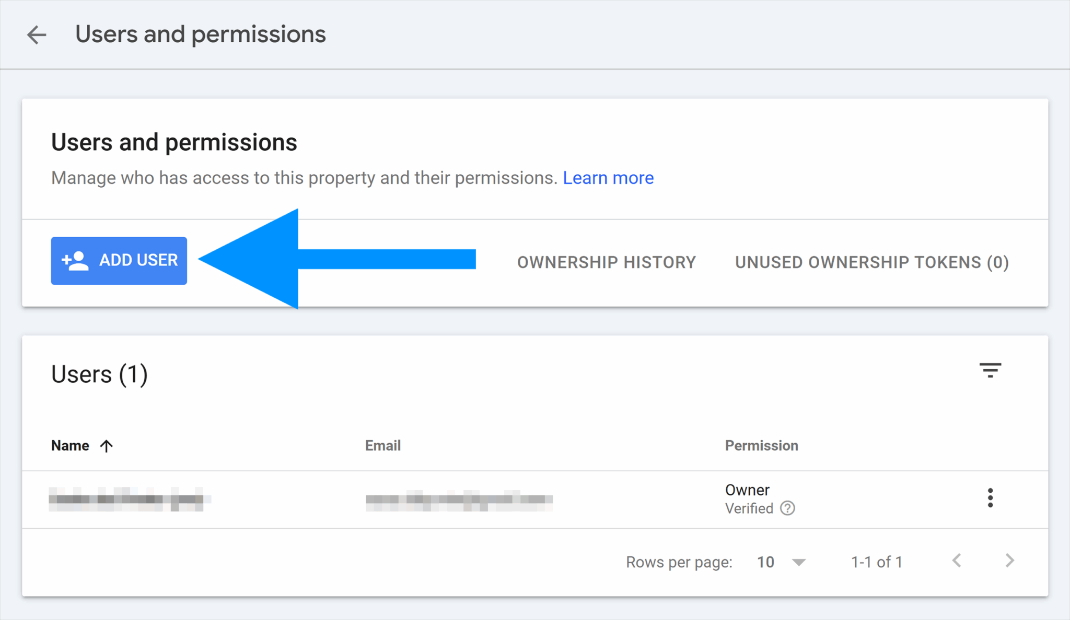
- Type in the person’s email address
- Choose their permission level: Full or Restricted
- Click “Add”
